UniStorm Version 1.6.0
By: Black Horizon Studios

Note: Most computers are fine but if you are a pro user and you are having problems with the terrain being cut or colored follow the below.

If you are using pro and have shadows enabled and you are having problems you need to run your rendering path, in the camera’s settings, set to deferred lighting in order for the dynamic snow shader to work properly. This is a Unity problem not a UniStorm problem, we are looking for a solution to fix this. It will be patched as soon as it’s figured out.

You can also follow the below on how to remove the snow shader which is what is causing the problems if you don’t want to run in deferred lighting.

Index

Getting Started and Setting Up….Go to

UniStorm Editor Info….Go to

Setting the Start Time….Go to

Setting Up UniStorm for Online…Go to

Changing the Speed of the Clouds….Go to

Adjusting the Sun Intensity...Go to

Adjusting the Sun’s Angle…Go to

Deactivating a Particle System or Effect…Go to

Too Dark in the Editor…Go to

Weather Command Prompt Codes…Go to

Horizon System….Go to

New Tools in the Editor (Important)…Go to

Stop Time…Go to

Make Weather Static….Go to

Turn Off Horizon System….Go to

Turn Off Dynamic Snow….Go to
Turn Off the WCPS…Go to
What’s new with Version 1.6….Go to

Customer Support/Contact….Go to

Getting Started

You may need to import the pro image effects if importing into your own project to avoid errors if not already done, this goes for the free version of Unity users too. Unity automatically disables the pro effects if you are not able to use them.

Setup is the same as 1.4.1 the system just has a updated name.
Getting the Prefab and Setting up

We have created 1 prefabed system for you to drop into your scene, simply go to the search and type in UniStormSystem_1.6.0 and you will see the prefab system. This has everything you need to recreate the exact quality of the demo scene, minus the terrain.

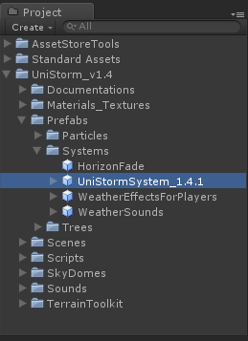

Drag the system into your scene and adjust it as needed. Make sure the camera’s far clipping plane is set to 15,000. Doing so allows you see UniStorm and its contents. (If you seem to be having clipping problems than set it a little higher) You will want to place the player given in your scene close to the ground and near your player so you can make the necessary changes. Try to make sure that the actual system is in the middle of your scene and that the sun and moon are passing over the middle of your terrain or scene. You can place you character wherever.

The “player” part in the prefab has all the effects attached to it that are needed to make UniStorm run. You can simply select all these effects (shown below) and transfer them over you your own player or camera (Don’t include our camera). This will make it easier because they are already connected with the UniStorm prefab and system. All you have to do is position them properly above your player or camera.

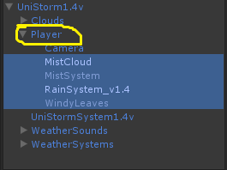

If you are using a 3rd Person controllers or any other camera other than the one we supplied, you will need to copy the effects that are on our camera and copy them over to your camera. You can adjust these as you want, but to make things easier you should copy everything exactly the same and then adjust them later to avoid any problems.

If you are using a 3rd Person Controller or any other camera other than the one we supplied, you will need to use a sunshaft image effect like we did with our camera, whether you have pro or not. Once both sunshaft image effects are on your camera, two meaning one for your Sun and one for your Moon, you will need to attach the Moon Directional light to the grey sunshaft, and attach the Orange sun shaft to the Sun Directional Light. This will allow UniStorm to controller the moon light glow and sun rises and sun sets properly.
Example below:
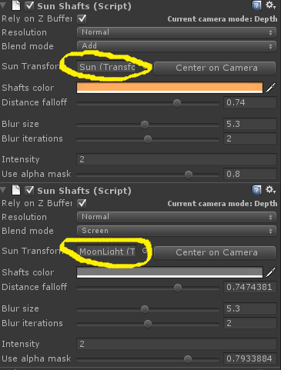

Lastly you will need to attach your camera to the UniStorm system where shown below.
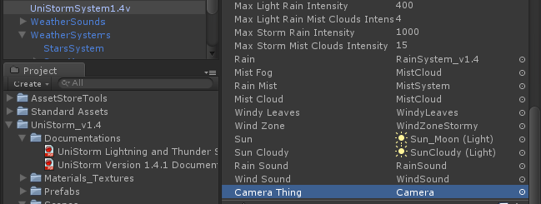

Once you feel like your done or close, test out the scene and create a storm by pressing 3 in the “Weather Forecaster” part in the UniStorm System editor. This will manually cause a lightning storm so you can see whether the effects are positioned correctly. If they are a little off just go back to the editor and position them better until you are satisfied with the results.

Activate and Deactivate

If you don’t like an effect you can deactivate it, this will allow UniStorm to still be able to access it, but it will not be shown or rendered. Some of you may not like the “MistSystem” effect, which is the big cylindrical streaking mist effect when it rains, or may look like just a line in front of you. If you don’t like it, just deactivate the “MistSystem” game object like shown below.
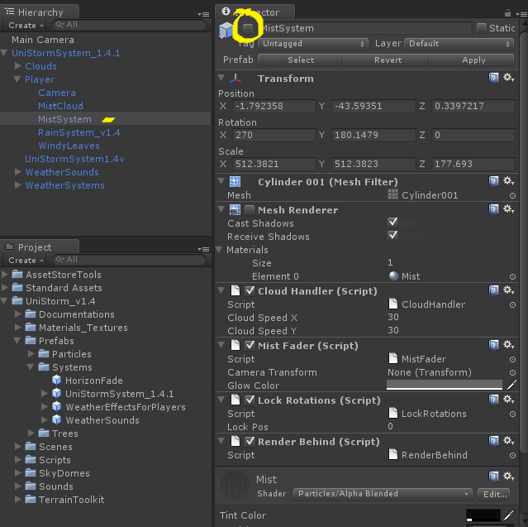

After you are done transferring everything over you and setting everything up like we have done you can adjust things however you want.

Optional set up:
We have also supplied a prefab with all the player’s effects called PlayersEffects in the prefab “systems” folder. You can use this if you want, but it’s more difficult because you will have to manually attach the effects to the UniStorm System. UniStorm will tell you what things are missing. Just go to the System and match the names with the particle systems from the PlayersEffects. Rain with the Rain particle system, Mist with the mist system, ect.

Too dark in editor

If it’s too dark in the editor you can adjust the sun directional light intensity and make it brighter, it will not affect the game. We have already done this, but you can make it brighter if needed.
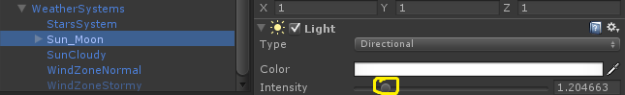

Demo Test Scene
We have created a test scene so you can see UniStorm 1.6 in action and to see how everything is setup. Get familiar with the UniStorm editor to see where everything goes. It may seem big, but it’s very simple and you’ll get the hang of it the more you use it.

If you have a problem with the UniStorm prefab simply copy the one from the demo and paste it in your scene.

UniStorm’s Time Tracker

You can see in the editor that UniStorm keeps track off your in-game time. It tracks minutes, hours, days, months and years, all at the speed of which you set you day length speed to. The day length is what you use to control how long your in-game days are. This is calculated in seconds, so if a setting of 60 would be a 1 minute day, if you set it to 1440 your days would 24 minutes, or a real time minute for every in-game hour. You can add GUIs to the variables of the time trackers if you wish to allow your players to be able to see the current in-game time. The system does run at fast speeds, but it performs best at a speed of 600 or more. We like the setting of 4800, it’s similar to Skyrim.

Using UniStorm’s In-Game Time System

UniStorm has a powerful in-game time keeping system. This system allows you to have quests or events happen at any time, hour, day, month, or year. AI and Waypoint systems can all easy access the in-game time allowing for realistic, believable, and dynamic gameplay.

An in-game example script has been included to show how you can access the in-game time. This example turns on a light for night and turns it off during the day.

Moon Phase Change Time and Start Time

This setting is done by decimals due to the way our system is setup. If you want to start the game at night set the start time to 0 and the moon phase change time to .4. If you want to start the game during the day put the start time to .4 and the moon phase change time to 0.

Weather Forecaster

UniStorm randomly creates forecasts and is updated every hour so the weather can start on any day at any hour. The length and strength of each storm varies because UniStorm randomly chooses how long a storm will be. The longer the storm, the more powerful it gets.

If you wish to adjust this, it allows you to choose your starting weather or to manually start a weather forecast. If you are using an online game this is the function you would use to send numbers to start certain weather types.

Weather Command Prompt System Commands

WCPS (Similar to Skyrim/Oblivion's) will make it much easier for developers. This system allows users to enter a command in the command prompt system to change the weather while still in the game. (Example: 01 would be Foggy)
The WCPS can easily be enabled or disabled by pressing F12 or can be completely disabled by checking the disable system check box within the UniStorm editor.

This system is nice for testing, but shouldn’t be able to be accessed by players, as it’s mainly for testing and development purposes, WCPS is disabled by default.

To enable of disable see Turn Off WCPS in the index.

Here’s the list of WCPS commands

01 = Foggy
02 = Light Rain/Light Snow (Snow Winter Only)
03 = Thunder Storm/ Snow Storm (Snow Winter Only)
04 = Partly Cloud 1
05 = Partly Cloud 2
06 = Partly Cloud 3
07 = Clear 1
08 = Clear 2
09 = Cloudy
001 = Mostly Cloudy
002 = Heavy Rain (No Thunder)
003 = Falling Fall Leaves (Fall Only)
004 = Butterflies (Summer Only)

If you manually choose a weather type UniStorm will still generate forecasts. This is good for testing.

Weather Functions within the Editor

If you want to change the weather within the UniStorm editor, or set it before the game starts, you use the below commands.

1 = Foggy
2 = Light Rain/Light Snow (Snow Winter Only)
3 = Thunder Storm/ Snow Storm (Snow Winter Only)
4 = Partly Cloud 1
5 = Partly Cloud 2
6 = Partly Cloud 3
7 = Clear 1
8 = Clear 2
9 = Cloudy
10 = Butterflies (Summer Only)
11 = Mostly Cloudy
12 = Heavy Rain (No Thunder)
13 = Falling Fall Leaves (Fall Only)

Horizon System

The horizon is an additional feature, it masks and fades the clouds along the horizon making them look more realistic and natural along the horizon line. This doesn’t use any additional performance other than 1 draw call.

The horizon is adjustable for each time of day; morning, day, evening, and night. The color bars are the same as the other components you can adjust.

UniStorm Editor

You can see from the UniStorm Editor the time trackers, color controllers, and game objects where you would place your particle systems, such as rain, and mist or clouds. All this is already set up so you don’t need to adjust anything. If you wish to add your own custom particle system to UniStorm or change anything, it will be covered below.

Adjusting your Weather System’s Colors

If you’d like to adjust the color of the ambient light, background color, sunlight color, or storm cloud color you can by simply clicking the color bar and putting it to a desired color. If the scene is too dark at night adjust the ambient night color to a lighter shade of grey. If you’d like more moonlight, then you can make the sun color at night a dark shade of grey. The fog color settings are used to adjust the global fog colors (Pro Only). The brighter color you set it to the denser the fog is. If you want it to be less dense you set it to a darker color. You are free to adjust the fog, but the colors we have setup work best. The last color settings are the atmospheric colors of the sun and its light scattering (Pro Only). You can adjust these colors for day time, dusk, and dawn, but the colors we have supplied work and look the best.

Star System

This is for the star system object which cast the star system. You can click this and it will take you to the star system game object. You can change the material if you have your own custom material or texture, but make sure the material type is set to Particle/Additive in order for UniStorm to properly shade it.

Moon Object

This is our moon object; you can click it to see the Moon game object. The only thing we recommend you adjust is the Moons material color; if it’s too bright, or the size of the moon.

If you move or rotate the moon game object (which we don’t recommend) it might mess up the way it properly faces your terrain, but if you wish to have the moon rotate more close to the horizon line instead directly overhead, then you can just make sure it is properly set up and facing the terrain.

Moon Phases

These are all the moon phase materials; we have supplied 9 transitioning to full and back. If you want to change these with your own custom materials you can just make sure the material type is set to Unlit/UnlitAlpha.

Max Particle Amounts

These are both the max mist and rain for both light rain and storm weather types. You can adjust these as you like if you’d like. The settings we have are optimized to efficient and look good though. Here’s the settings like explained above.

The particles get capped based off max rain and max mist to stop the particles from getting too high. You can adjust the max of both the rain and mist if desired and UniStorm will not go above the max numbers you’ve inputted. There are two maxes, one mist and rain for light rain, and one mist and rain for stormy weather. The settings we have set are both efficient and look good, but you are welcome to change them as you please.

For light rain we used: Max Rain = 400 and Max Mist = 4
For the storm we used: Max Rain = 1000 and Max Mist = 15

Particle Systems
The next few object types are the particle types; rain, mist, and windy leaves. You can disable windy leaves if desired. If you wish to add the rain front system to UniStorm just change the Rain1.4 system to the Rain Front System and UniStorm will handle everything else, just make sure everything is enabled in the Rain Front System.

UniStorm Lightning and Thunder

The lightning and thunder system is covered in the other documentation and will tell you everything you need to know. UniStorm automatically enables and disables this only when there is a storm.

Unity 3d Fog Support

UniStorm now supports Unity’s built in fog. Cloud color or shade is now based off the fog color as well as the light from the sun or moon. You can adjust these for each time of day just as you have with the previous color bars.

Adjusting Fog Density
Fog density can be changed in the UniStorm editor. We recommend having it at no more than .002, but you are free to do as you please.

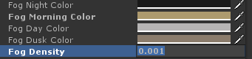

Blended Skyboxes

UniStorm now uses blended skyboxes allowing for dynamic skies, this allows the sky to be multiple shades at each time of day just like a real sky, rather than it all being one shade. This is all adjustable by the user with the 4 times of day color bars just like with the other settings. We use this instead of the camera background color as it looks much better. This is located right after the fog density.
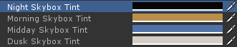

New Tools in the UniStorm 1.6 Editor

UniStorm 1.6 has added new tools to the editor making it much easier for development. These are all checkboxes, you check them if you want that feature enabled.

* Time Stopped – This will stop the time 100% and it will never change.

* Static Weather – This will stop the weather from changing. Whatever weather you have at start up will be the weather, unless you manually change it using the command prompt or the weather function numbers.

* Time Scroll Bar – This will enable the time scroll bar at the top left part of your screen when playing. This scroll bar controls the time of day so you can scroll to different times for testing or demonstration purposes, time still flows though.

* Horizon Toggle – This will toggle the new horizon system on or off. The horizon is an additional feature but don’t need to be used. It masks and fades the clouds along the horizon making them look more realistic and natural along the horizon line. This doesn’t use any additional performance other than 1 draw call.

* Dynamic Snow Enabled – This controls weather or not you want to have dynamic snow enabled. Note: Not that dynamic snow does use a little more performance that the regular terrain shader.

Deactivating Dynamic Snow

If you want to disable dynamic snow you will uncheck the Dynamic Snow Enabled checkbox in the UniStorm editor; be sure to do this or it will cause an error, and delete the CustomTerrainScriptAtsV3Snow script. This will allow the normal terrain shader to be used and allow UniStorm to skip the dynamic snow shader functions without causing errors.

* Weather Command Prompt System – This will disables or enables the WCPS. This system is nice for testing, but shouldn’t be able to be accessed by players, as it’s mainly for testing and development purposes.

Changing the Cloud Speed

The cloud speed variable can be found in the UniStorm Editor. The default setting is 3. You are free to use whatever speed you want. This only works if the day length is at a speed of greater than 50.

Adjusting the Sun Intensity

The sun intensity variable is found within the UniStorm editor. There are 2 sun controls; if you want to adjust the sun intensity you will adjust both the Sun Intensity and the Max Sun Intensity to the same number. These 2 variables are what allow the smooth sun fading transitions.

Adjust the Sun Angle

The Sun Angle variable tilts the sun as it would in real life. The number -10 and 10 are the optimal maxes, each getting closer to the left or right of the horizon. A setting of 0 makes the sun shine straight down, like it would if it were summer. It’s best to adjust this while playing the game so you can find a number angle that works for you. A setting of 0 makes it hard to see the details and hills in the terrain. So a setting of 2 to 3 or -2 to -3 are best.

Moon Shader Bump Spec

We’ve also added a transparent bump specular moon shader to allow even more realistic moon shading and look. If you wish to add this just switch the moon shaders on the materials to the bump specular moon shader.

Setting UniStorm Up for Multiplayer or Online
If you want to get UniStorm to work with a multiplayer design all you have to do is allow the server to send out state syncs to all players in a zone or room and let the clients handle them. It is a pretty simple setup:
1.) Take the calculations from UniStorm and create a system server side to send out the current state.
2.) Modify the client to handle these state syncs instead of generating its own weather it would generate weather based on the current state of the system running on the server.
Just make sure your players each have their own UniStorm system that will not be synced across the network to other players but only handled locally.

UniStorm Version 1.6 Changes

UniStorm Version 1.6 Features:
* Normal cloud speed can now be adjusted within the editor.
* HD photo realistic cloud textures; 8 included
* Realistic storm transitions
* SSAO, Color Correction, and HDR support allowing for incredibly realistic time of day, lighting, color, shading, and light scattering
* Realistic and improved skies; like Skyrim's
* Random temperature generator for each season controlling whether it rains or snows; as well as other weather types
* Seasons; Spring, Summer, Fall, and Winter
* Seasonal weather for all 4 seasons
* The new advanced weather system algorithm controls the weather odds for each season, Summer has less precipitation chances than Winter or Spring; seasons can be changed by the user if desired
* Snow storms in the Winter, Misty cloudy days in the Spring, fluttering butterflies and thunder storms in the summer, falling fall leaves in the fall, and more.
* Many new weather types added
* Storm clouds are now affected by time of day
* In-game event example with demo and script using UniStorm's powerful in-game time system
* Dynamic snow on all models, terrain, and terrain vegetation when it snows
* Night ambiance noise for when it's night
* In-game time system event examples with demos
* Weather command prompt system (more info below)
* Horizon system that fades clouds along the horizon line for improved looking skies.
* The horizon system has color control for morning, day, dusk, and night.
* UniStorm's snow system will now be able to work with Unity's terrain, trees, and grass as well as all 3d models and objects.
* Snow build up will be dynamic and up to how powerful the snow storm is, and if it's cold enough. You could have light snow showers with light snow build up or a snow storm with full snow cover.

UniStorm Version 1.6 Fixes and Improvements:
* Fixed storm transitions, sunlight will now gradually fade when it gets cloudy or there's precipitation, then fade back in after a storm is over or the clouds have cleared.
* Improved lighting bolt textures
* Improved splash particle textures
* Improved rain particle textures
* Improved sun textures
* Improved cloud system by using both high and low clouds
* Improved light scattering (Pro Only)
* Greatly improved fog weather type (Pro Only)
* Greatly improved storm clouds
* Greatly improved documentation
* Greatly improved dynamic weather randomizing algorithm
* A check box has been added to disable or enable stopping the time 100%.
* A check box has been added to disable or enable the weather static, meaning it will never change.
* A check box has been added to disable or enable the time of day scroll bar.
* A check box has been added to disable or enable the horizon system.
* The weather will no longer change too often (within minutes sometimes), between 1 to 10 in-game hours must pass in order for another weather change.
* If there is precipitation for more than 3 days, the system will randomly pick a new weather type. (The days of this can be adjusted)
* If there hasn't been any precipitation in 7 in-game days, the system will randomly generate precipitation. (The days of this can be adjusted)
* Other Improvements and tweaks to the system
* All this and still the same blazing fast frame rate that no other weather systems can match!

Customer Support

If you have any questions or problems we’re here to help you out. You can email us at BlackHorizonStudios@juno.com and we will help resolve your issue.

Thank you for purchasing UniStorm and if you like it don’t forget to rate.

